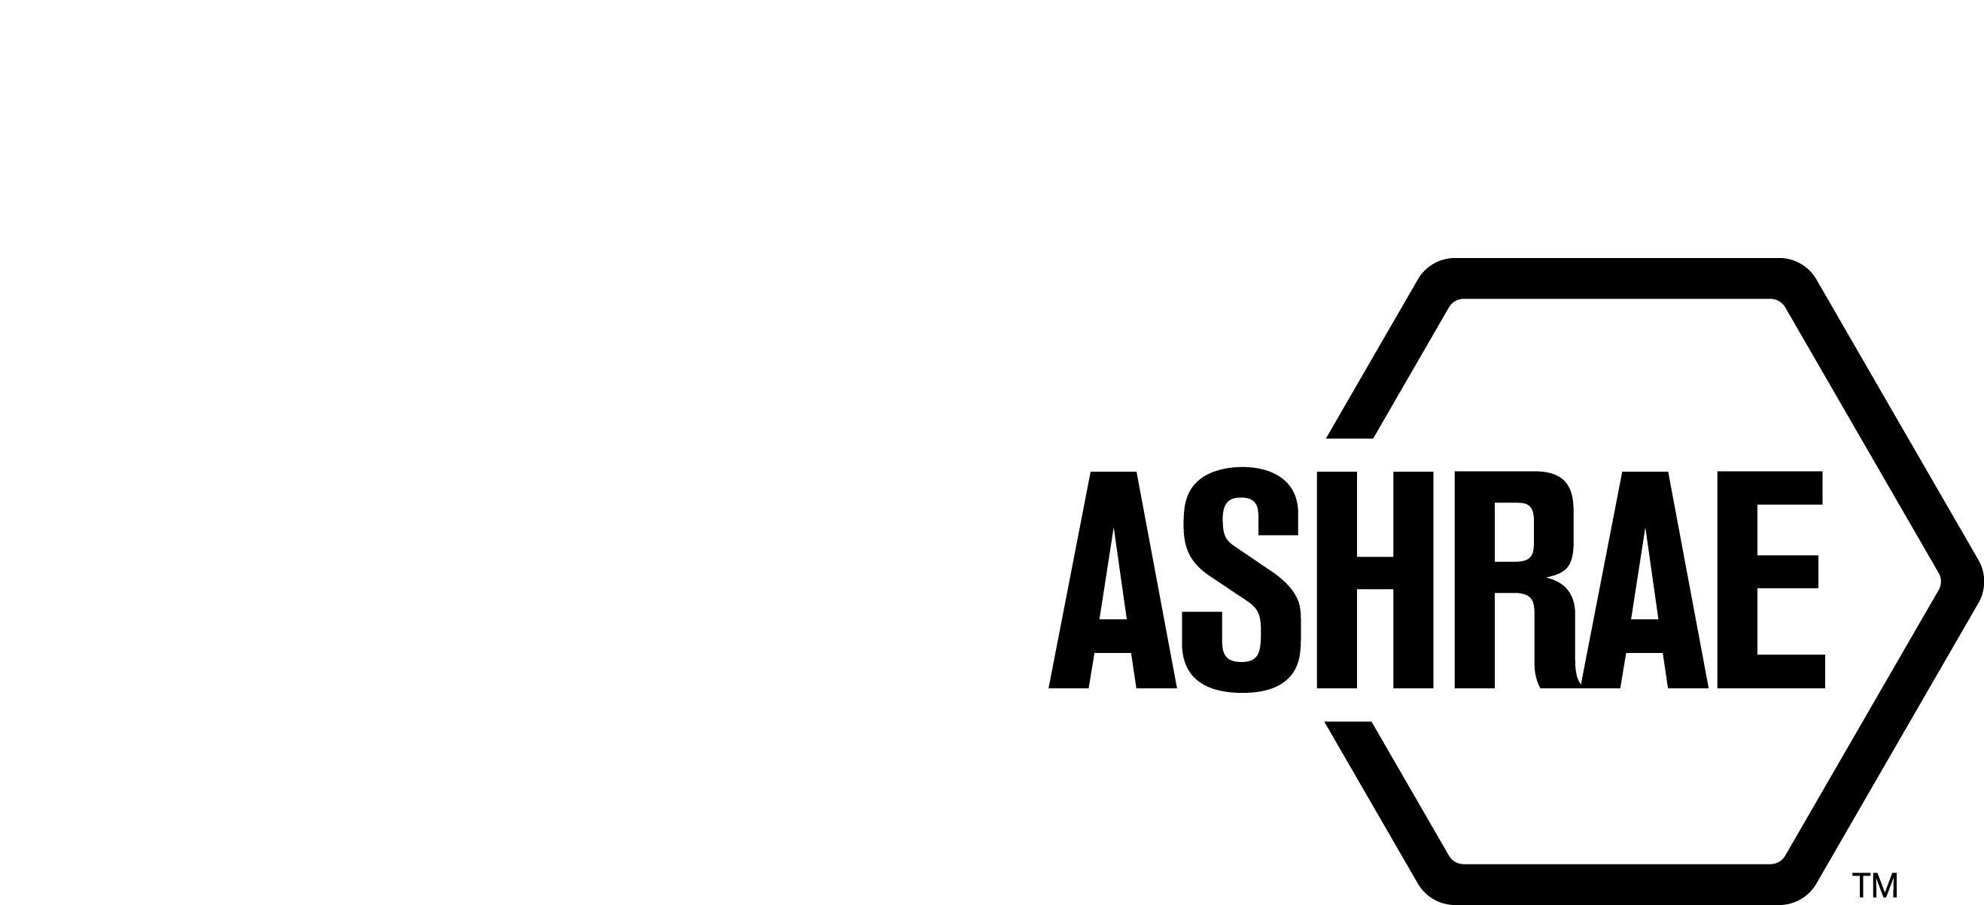

PLANNING, POLICY AND INTERPRETATIONS SUBCOMMITTEE (PPIS)

MINUTES

Fall Meeting
Conference Call
Meeting of September 13, 2023

NOTE: These draft minutes have not been approved and are the unofficial record by PPIS.

TABLE OF CONTENTS
1. Call to Order/Introductions and Review of Agenda 3
2. Chairman’s Report 3
3. Staff Report 3
4. Approval of Minutes 3
5. Review of Action Items/Unfinished Business 3
6. Planning – New Projects 4
7. Policy – Procedural Changes 5
8. Interpretations 6
9. New Business 6
10. Recess 6

ACTION ITEMS ASSIGNED SUMMER MEETING 2023
AI# | Action | Assigned To | Status
1 | StdC assigned PPIS to revise procedures as needed to coordinate with new GTIC (Global Technical Interaction Committee) and Standards adoption.  8/25/2023 - Action item is postponed until Staff review is conducted. | PPIS | ONGOING

1. Call to Order/Introductions and Review of Agenda

Call to Order/Chairman’s Report

The Planning, Policy and Interpretations Subcommittee (PPIS) meeting was called to order on Wednesday, September 13, 2023, at 11:00 a.m. via teleconference.

Introductions

Chairman Bill Walter greeted members and guests.

PPIS Members  William (Bill) Walter, Chair  Kelley Cramm  Drake Erbe  Julie Majurin  Karl Peterman  Christopher Seeton | PPIS Members Absent  Guests  Alex Schmig | Staff  Tanisha Meyers-Lisle, AMOS-A

2. Chairman’s Report
Chairman greeted guests and discussed the ASHRAE Code of Ethics, Anti-Trust Guidelines and the prohibition of recording meetings.

3. Staff Report
Staff reported there were 5 appeals received in response to the publication approval of BSR/ASHRAE Addendum j to ANSI/ASHRAE Standard 62.2-2022, Ventilation and Acceptable Indoor Air Quality in Residential Buildings. Addendum j to ASHRAE Standard 62.2 seeks to address the operation of unvented combustion space heaters in 62.2 compliant dwellings. The Appeals Panel voted to dismiss the appeal. The appellants filed a complaint with ANSI and we submitted our rebuttal on July 14, 2023. The ANSI ExSC had additional follow up questions that required a response. Staff submitted the response on September 12, 2023.

4. Approval of Minutes
The PPIS Minutes from the Annual Meeting 2023 was presented to members for approval.

It was moved by Chris Seeton and seconded by Julie Majurin:

- That the PPIS Minutes from the Annual Meeting 2023 be approved as
written.

MOTION 1 PASSED: 4-0-1, CNV
Secretary’s Note: Kelley Cramm abstains as she was not present.

5. Review of Action Items/Unfinished Business
5A. Action Items
A list of action items was presented to members for review. An update of the action items is presented on page 2. PPIS members will continue to review their assigned action item(s).

6. Planning – New Projects
It was moved by Kelley Cramm and seconded by Karl Peterman that:

2 The following Title, Purpose and Scope be approved and a new Standard Project Committee be formed:

TITLE: Safety Standard for Transportation Refrigeration Systems

- PURPOSE: This standard specifies safe design, construction, installation, and
operation of refrigeration systems for use in transportation application.

2. SCOPE: This standard establishes safeguards for life, limb, health and property
and prescribes safety requirements.

This standard applies to:

2.1 The design, construction, test, installation, operation and inspection of mechanical refrigeration systems including heat-pump systems used in transportation applications including: Land and Marine based refrigeration, and air conditioning systems for large trucks, busses and trains.

2.2 Modifications, including replacement of parts or components if they are not identical in function and capacity.

2.3 Substitutions of refrigerants having a different designation.

DISCUSSION: Chris speaks against motion; this doesn’t fall under ASHRAE but SAE. There is no ASHRAE agreement between the two.
Drake asks how does this effort involve 15? Alex states SSPC 15 isn’t involved. Some members are using Standard 15. Drake asks if ISO 5149 is not involved either? Alex responds correct.
Julie states when read, it seems like the scope and purpose are the same as Standard 15, but notes there are differences that Standard 15 doesn’t include, i.e., container on truck/train and then it goes on a ship, maybe that was discussed but didn’t see it in the description.
Alex states in the scope we listed land and marine based, so given that scope, it would fall under definitions of what each of those systems are, Standard 15 and Standard 15.2 have different occupancy definitions that will also be spelled out. Alex also states aerospace was left out, per the requests from TC 9.3.
Chris states we are blurring the lines and there are regulatory agents that deal with the safety on what is on our boats, roads, etc.
Kelley states we have a TC that is named Transport Refrigeration, etc., I think when it comes to refrigeration systems, we are the experts. The other thought I had, it’s refrigeration systems in transport applications not the transport of refrigerants. We are talking about refrigeration systems.
Bill asks if SAE covers container units? Chris states there is a gray area and it’s not coupled to a vehicle. Alex states that was one of the intended use case, refrigerated transport systems. But, also addressing air systems for busses trains and large trucks. Chris – we’re not just cars. Karl asks, is there no safety standard currently among any SDO, or are we filling a gap that exists? Alex responds yes. Karl speaks in favor of the motion; and states we are the experts in refrigeration systems.
Drake asks is the intention of this standard to have global application? Alex states, I think it could be. Drake asks, have you identified a number of projects that are off shore US? Alex responds yes, they are relevant topics in Europe right now. Drake asks if there has been any participation with some of those folks. Alex responds, yeah.
Drake votes in favor of the motion if this was wider and there will be global interface and participation in developing the standard.
Bill states, regulatory bodies can refer to this and they should be involved early on. Alex agrees and thinks this has the opportunity to be adopted by 15.
Julie states, Standard 15 doesn’t refer to equipment that moves across borders. That may be an issue; it hasn’t been considered adequately. Julie would like to see a broader scope.
Drake states, harmonization may be an issue when developing this standard. Standard 15 and ISO 5149 don’t agree.
Karl states, consideration is different from harmonization and the European documents don’t need to be harmonized.
Chris SAE standards are ANSI standards. Alex asks are we stepping on an ANSI standards toes? No response.
Karl Peterman offered two other aspects after the meeting:
- Our procedures (and ANSI) do not prohibit overlap of other ANSI standards but do require sincere effort to harmonize and documentation and justification for those overlaps.
- If this proposed standard ends up overlapping the SAE standard (or any other ANSI standard) then that will have to be documented and justified – and could be a basis for disapproval if the harmonization efforts are deemed inadequate. It will be incumbent on the project committee to adequately address the issue(s)…

BACKGROUND: This TPS will also have to be approved by the Board. This TPS was submitted by Alex Schmig for reconsideration at the Fall PPIS meeting. PPIS assigned the TC 10.6 as the cognizant committee and TC 9.3 as the co-cognizant committee. Alex Schmig was recommended as the Chair of the proposed new project committee. There are at least five members willing to volunteer.

MOTION 2 PASSED: 4-2-0, CV
Secretary’s note: Chris Seeton and Julie Majurin voted against the motion because they believe the scope is too broad.

7. Policy – Procedural Changes
None.

8. Interpretations
None.

9. New Business
None.

10. Recess
PPIS adjourned at 12:14 pm.

